**LAB 4-5 – REQUIREMENT SPECIFICATION**

*NGUYỄN TOÀN PHÚC - ITITIU21093*

*NGUYỄN MINH ĐỨC - ITITIU21045*

**I. Use Case Diagram**

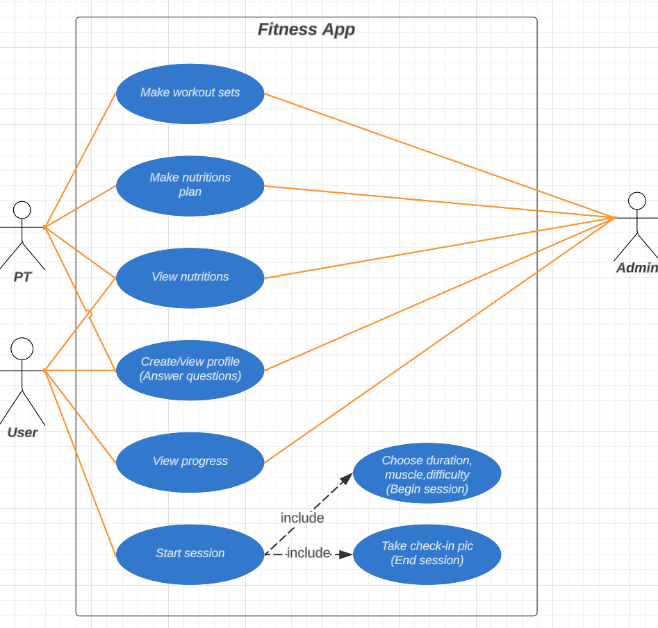

**II. Use Case Description**

**1. Title: Create/View Profile**

* Identifier: UC1
* User Story: As a new user, I want to create my profile and view it later.
* Input: Name, age, and other personal information / Change profile
* Output: Invalid information / Profile saved
* Preconditions: The user is logged into the app.
* Basic Course:
  + 1. User navigates to the profile section of the app.
  + 2. User selects the "Create Profile" option.
  + 3. The app prompts the user to input their personal information, such as name, age, gender, and fitness goals.
  + 4. Users input their information and save it.
  + 5. The app displays the user's profile information, which the user can view or edit at any time.
* Alternative Course: If the user inputs invalid information, an error message is displayed, and the user is prompted to correct their input.
* Postconditions: The user has a profile that they can view or edit at any time.

**2. Title: Start Session**

* Identifier: UC2
* User Story: As a user, I want to start a workout session on the app.
* Input: None
* Output: Workout session started
* Preconditions: The user is logged into the app and has access to the workout features.
* Basic Course:
  + 1. User opens the app and navigates to the workout section.
  + 2. User selects the "Start Session" option.
  + 3. The app prompts the user to choose a workout type or category.
  + 4. User selects the desired workout type or category.
  + 5. The app starts the workout session and displays relevant information, such as exercise instructions, duration, and progress.
* 6. User performs the workout according to the instructions provided.
* Alternative Course: If the user does not have access to the workout features, an error message is displayed, and the user is prompted to upgrade their account or subscribe to a premium plan.
* Postconditions: The user is engaged in a workout session and can track their progress and complete the session.

**3. Title: View Progress**

* Identifier: UC3
* User Story: As a user, I want to view my progress on the app.
* Input: None
* Output: Progress data displayed
* Preconditions: The user is logged into the app and has completed one or more workouts.
* Basic Course:
  + 1. User navigates to the progress section of the app.
  + 2. The app displays progress data, such as workout history, calories burned, and weight loss/gain.
  + 3. Users can view their progress data and track their fitness journey.
* Alternative Course: If the user has not completed any workouts, an error message is displayed, and the user is prompted to start a workout session.
* Postconditions: The user can view their progress data and track their fitness journey.

**4. Title: View Nutritions**

* Identifier: UC4
* User Story: As a user, I want to view nutrition recommendations on the app.
* Input: None
* Output: Nutrition recommendations displayed
* Preconditions: The user is logged into the app and has completed their profile information.
* Basic Course:
  + 1. User navigates to the nutrition section of the app.
  + 2. The app displays nutrition recommendations based on the user's profile information, such as recommended daily caloric intake and macronutrient ratios.
  + 3. Users can view their nutrition recommendations and track their dietary intake accordingly.
* Alternative Course: If the user has not completed their profile information, an error message is displayed, and the user is prompted to complete their profile before accessing nutrition recommendations.
* Postconditions: The user can view their nutrition recommendations and track their dietary intake accordingly.

**5. Title: Make Workout Sets**

* Identifier: UC5
* User Story: As a personal trainer, I want to create workout sets for my clients to follow on the app.
* Input: Exercise instructions, duration, sets/reps, etc.
* Output: Workout sets created
* Preconditions: The personal trainer is logged into the app and has access to client profiles.
* Basic Course:
  + 1. Personal trainer navigates to the client's profile section of the app.
  + 2. Personal trainer selects the "Create Workout Set" option.
  + 3. The app prompts personal trainers to input exercise instructions, duration, sets/reps, etc.
  + 4. Personal trainer inputs workout set information and saves it to the client's profile.
  + 5. The workout set is displayed on the client's app and can be accessed during workout sessions.
* Alternative Course: If a personal trainer inputs invalid information, an error message is displayed, and the personal trainer is prompted to correct their input.
* Postconditions: The personal trainer has created a workout set for their client to follow during workout sessions.

**6. Title: Make Nutrition Plans**

* Identifier: UC6
* User Story: As a personal trainer, I want to create nutrition plans for my clients to follow on the app.
* Input: Dietary restrictions, caloric intake goals, macronutrient ratios, etc.
* Output: Nutrition plans created
* Preconditions: The personal trainer is logged into the app and has access to client profiles.
* Basic Course:
  + 1. Personal trainer navigates to the client's profile section of the app.
  + 2. Personal trainer selects the "Create Nutrition Plan" option.
  + 3. The app prompts personal trainers to input dietary restrictions, caloric intake goals, macronutrient ratios, etc.
  + 4. Personal trainer inputs nutrition plan information and saves it to the client's profile.
  + 5. The nutrition plan is displayed on the client's app and can be accessed during meal planning and tracking.
* Alternative Course: If a personal trainer inputs invalid information, an error message is displayed, and the personal trainer is prompted to correct their input.
* Postconditions: The personal trainer has created a nutrition plan for their client to follow during meal planning and tracking.

**III. Entity Relationship Diagram**

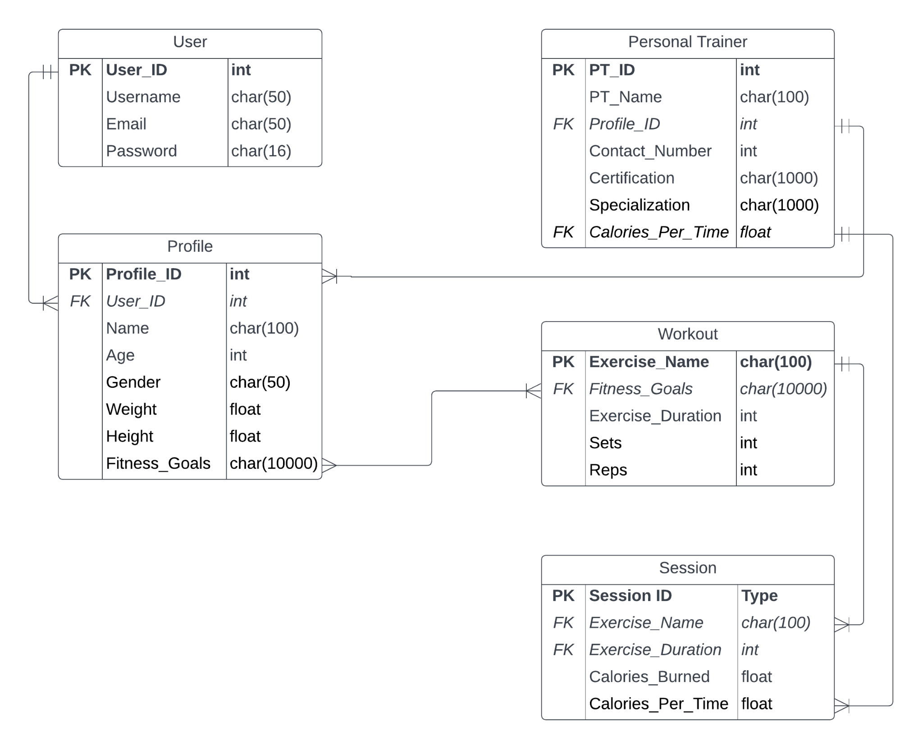**IV. Class Diagram**

